How to view Travel Requests in workflow

On the Concur menu, select “Request” and “Process Requests”. Concur will list Travel Requests ready for processing in workflow.
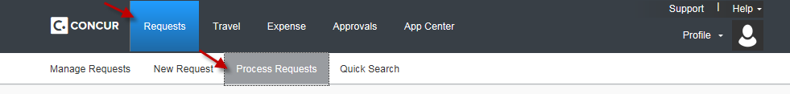

You can refine your search by clicking on the dropdown box, selecting an appropriate item, and clicking on “Go”.
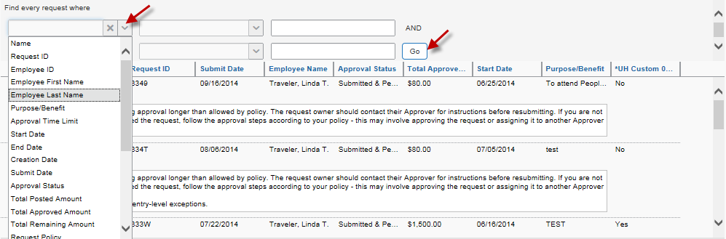

You can further refine your search by the “Run Query” button and selecting a category.

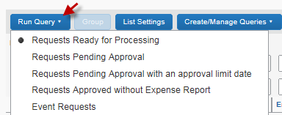

You can also add more information about TRs by the “List Settings” button and selecting additional fields.

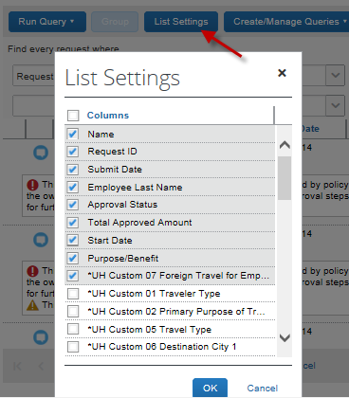

How to view Expense Reports in workflow

On the Concur menu, select “Expense” and “Process Reports”. Then Click on the “Preferences” button to adjust the list restrictions. If you want to view all Expense Reports in workflow, you would need to select “No” for “Limit queries to reports dated within”.

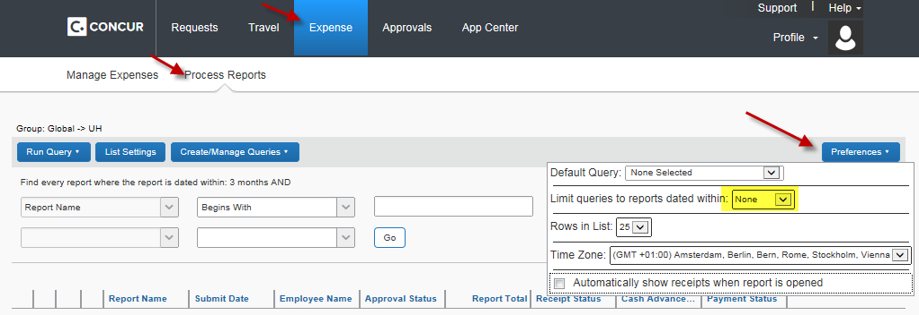

Click on the dropdown box and select an appropriate item and enter value or “%”. Then click on “Go”.
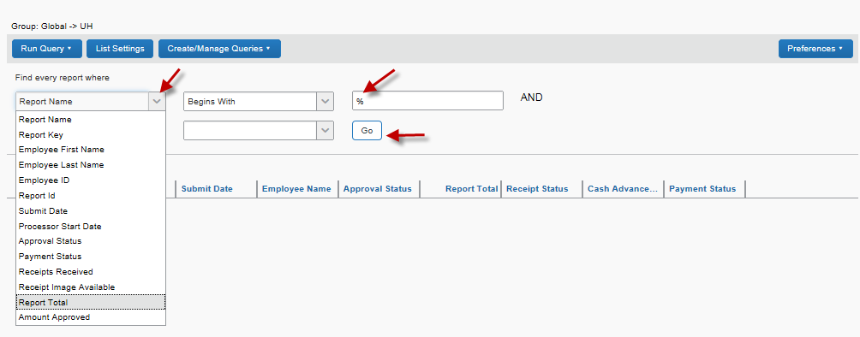

You can further refine your search by the “Run Query” button and selecting a category.

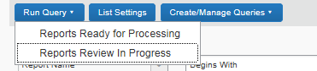

You can also add more information about TRs by the “List Settings” button and selecting additional fields.
